Student Records Requirements &
Best Practice Guidelines

October 2014
Updated: 2015-09

Beachcombers Academy

Contents
INTRODUCTION 3
REFERENCE SOURCES 3
PERSONAL INFORMATION PROTECTION ACT (PIPA) 3
RESPONSIBLE PERSON 4
STUDENT RECORD GUIDELINES COMPONENTS 4
PART I – PERMANENT STUDENT RECORD - Transferable 4
PART II – ADDITIONAL STUDENT RECORD ITEMS – Non-transferable 6
PART III – ACCESS TO AND DISCLOSURE OF STUDENT RECORDS 8
PART IV – TRANSFER OF STUDENT RECORDS 9
PART V – COMPLAINT PROCEEDURE 10
PART VI – QUICK REFERENCE CHART 11
APPENDIX I – ELIGIBLE STUDENT INFORMATION 12
APPENDIX II – STATUS OF PARENT/GUARDIAN (ADMISSION TO CANADA AND RESIDENCY) - FORM A 13
APPENDIX III – STATUS OF DECEASED PARENT (ADMISSION TO CANADA AND RESIDENCY) - FORM B 14

INTRODUCTION

The Personal Information Protection Act (PIPA) came into effect on January 1, 2004. It covers the collection and disclosure of personal information.

The Federation of Independent School Associations (FISA) developed a draft policy document on best practices for student records in 2012. This policy is based on the FISA document, but has been adapted to meet the needs of Beachcombers Academy.

The intent of the policy is to benefit the school students, parents, office staff, administrator and the board by providing guidance for the collection of information and its storage, use, transfer, and protection.

Legal and public expectations regarding the confidentiality, disclosure and transfer of school student records are increasing, as well as societal concerns regarding school record keeping and storage.

REFERENCE SOURCES

PIPA:
http://www.bced.gov.bc.ca/independentschools/is_resources/pipa_act.htm

General information on PIPA may be found at:
http://www.oipc.bc.ca/tools-guidance/guidance-documents.aspx
http://www.oipc.bc.ca/for-private-organizations.aspx

The Independent School Act (section 6.1), sections 9 and 10 of the Independent School
Regulation (the Regulation), and the Student Records Order (I 1/07):
http://www.bced.gov.bc.ca/legislation/schoollaw/k/i1-07.pdf

PERSONAL INFORMATION PROTECTION ACT (PIPA)

The Personal Information Protection Act (PIPA) came into effect on January 1, 2004. Three basic principles in PIPA are:

1. Independent school authorities must not collect, use or disclose personal information
without the consent of the individual (unless otherwise permitted under PIPA).

2. On or before collecting personal information about an individual from the individual,
independent school authorities must disclose to the individual verbally or in writing
the purposes for the collection and, on request, contact information.

3. Independent school authorities may only collect, use or disclose personal information
for the purposes that a reasonable person would consider appropriate in the
circumstances and that fulfill the purposes the independent school disclosed or are
otherwise permitted under PIPA.

Under PIPA, students, parents and employees have the right to access their own personal
information held by independent schools. Furthermore, under PIPA, a parent or guardian of a
minor may exercise the rights of the minor to access personal information of the minor if the
minor is incapable of exercising this right under that section of PIPA. Moreover, the
commissioner under PIPA can investigate complaints about independent school authorities'
handling of personal information.

RESPONSIBLE PERSON

The Principal is responsible to ensure that Beachcombers School complies with PIPA. The Board of Directors is responsible to establish and update the Student Records Policy.

STUDENT RECORD GUIDELINES COMPONENTS
The term “student record” as defined in the Independent School Act and referenced in these
guidelines refers to a record of information in written or electronic form in respect of a student,
but it does not include a record prepared by a person if that person is the only person with access
to that record. The “Permanent Student Record (PSR)” as defined in the Student Records Order
is a specific subset of student records. While the PSR is distinguished from additional record
items in this document, the on-site placement of the various student record items (e.g., whether
records are housed in one or more folders and/or locations) is matter of each independent
school’s local policies and procedures.

Schools should follow the Ministry of Education’s Form 1704 Completion Instructions
(http://www.bced.gov.bc.ca/classroom_assessment/psr_instruct.htm). Of particular note are
instructions regarding medical and legal alert inclusions and recording of achievement and
attendance (if letter grades are not assigned in grades 4-9, a brief description of the student’s
progress with reference to expected outcomes for students of that age/grade needs to be recorded
on or attached to the 1704).

PART I – PERMANENT STUDENT RECORD - Transferable

When a student transfers to another school, the following items are to be transferred to a school upon receipt of a request for student files.

A. Elements of the Student Record (Student Records Order, Section 2)
Required Items:

1. The Permanent Student Record, currently defined as the 1704 form.
2. Copies of a minimum of the two most recent years of Student Progress Reports.
3. Individual Education Plan (IEP) where applicable.

B. Permanent Student Record (Form 1704) Inclusions
Inclusions are documents (or copies of documents) used to plan or support a student’s
educational program. Not all students will have inclusions as part of their Permanent Student
Record. Inclusions are listed in the “Inclusion Section” on Form 1704, noting date entered,
title and expiry/rescinded date (if applicable). If the space for inclusions becomes full, it may
be necessary to create a second portion and attach it to the form for future additions.
Documents listed as Permanent Student Record inclusions on Form 1704 become
components of the Permanent Student Record and are required to be transferred with Form
1704 if the student enrolls in another school.

1. Student Record Required Inclusions
The following items must be filed with Form 1704, and dated and listed as an inclusion in
the appropriate section on Form 1704, for any student to whom these may apply:

a) health services information as indicated by the medical alert checkbox (see Form1704) such as diabetes, epilepsy, anaphylaxis producing allergies, blood clotting disorders, and serious heart conditions; any other condition which may require emergency care (after consultation with health care professional);
situations/conditions which may interfere with student performance, health, or
behavior (hearing aids, prescribed medication, cerebral palsy, cystic fibrosis, etc.);
and severe allergies in K-3 students to school based allergens

b) court orders as indicated by the legal alert checkbox (see Form 1704) or their
rescinding date if applicable;

c) other legal documents (e.g. name change or immigration document);

d) support services information (e.g. psychometric testing, speech and hearing tests, adjudication requirements for completing assessment activities);

e) Individual Education Plans (IEP’s) or Case Management Plans (CMP’s);

f) Notification of student being homeschooled

2. Student Record Optional Inclusions
The following optional inclusions may be listed on Form 1704 but are not required:
a) standardized test scores;
b) records of information which an educator deems relevant and important to the
educational program of the student;
c) award information (Ministry awards information should include year, date and serial number of the award).

Note: If the principal chooses to list an item as an inclusion, then it is required that the
document(s) supporting the item listed be filed with Form 1704 as an inclusion and these
items then become part of the Permanent Student Record. The principal may wish to
acquire specific consent for these optional items to be included.

If the principal chooses not to include the previous optional items on Form 1704 as a PSR inclusion, it may include them as additional Student Record items (see Part II –
Additional Student Record Items) but should take note that these items are then NOT part
of the Permanent Student Record.

Form 1704 Currency and Format
The student record shall be updated annually, or prior to a student transferring to another school, whichever comes first. The principal is responsible to ensure that 1704`s are completed and kept up to date; and that any relevant inclusions are noted. A completed Form 1704 must be in every student’s Permanent Student Record.

D. PSR Retention

The PSR shall be retained until another school requests the PSR or for 55 years
after a student has withdrawn and not enrolled in another K-12 school, or graduated from the
school. Permanent Student Records should be stored securely in a locked fire-proof cabinet.
If a student record is to be disposed of, it must be properly shredded.

If a student withdraws from an authority’s school and enrolls in another K-12 educational
institution, the authority must, upon request from the enrolling K-12 educational institution,
transfer the PSR.

Additional student record items (see Part II below) are not part of the transferable Permanent Student Record.

PART II – ADDITIONAL STUDENT RECORD ITEMS – Non-transferable
For school use only and not part of the Transferable Recor.
Additional student record items are not part of the transferable Permanent Student Record. These are to be retained for 10 years following graduation or withdrawal, with the exception of photograph consents which are to be kept indefinitely.
These include.
- Registration forms and emergency contacts.
- Signed consent forms (photograph, financial agreements, behaviour documents, etc.)
- Student discipline records.
- Documentation of communications with parents.

Please see section and may be returned to students, disposed of, or retained
The following items must be retained for a minimum of 10 years:
- consent forms (with the exception of photograph consents which must be kept indefinitely);
- student discipline records. must be retained for 10 years. according to school policy.

NOTE: Student discipline records may provide critical evidence for future dispute situations.

All student files are to be kept in a locked fire proof cabinet.

A. Additional Items--non-transferable:
1. Required Items
The following items must be included in student records to establish student eligibility
for funding and ensure that student health and safety information is complete:
a) legal name of child - verify the original and file a photocopy or scanned copy of birth certificate or similar legitimate identification document;

b) official name(s) of parent(s) or guardian(s) with home and work contact information, and emergency contact information (as requested in the Beachcombers Registration Form);

c) document verifying the information about the student’s parent or guardian in respect of students eligible for funding (see Appendices for verification details and suggested document format for inclusion in school registration)

Beachcombers Updating of Information:
Administration staff ensure that parents are asked at the beginning of each school year to update all contact information. Parents are further requested to provide updated information at any time that there are changes and are instructed to provide this information to the administrative assistant.

Contact information is updated by the administrative assistance. It is updated in the office binder, and is updated in the teacher binders for their emergency contact information. This is done periodically during the year as required to keep information up to date.

Access to Student Emergency Contacts: fieldtrips & evacuations

As stated in the fieldtrip and evacuation policies, teachers are required to carry a copy of the classroom binder with student emergency contacts on fieldtrips and during all evacuations. Classroom binders are to be kept in a secure, yet accessible, location. Binders are located so that they are easily accessed in the case of an evacuation. For fieldtrips they are kept by the teachers and may be retained in backpacks held by the teachers. A staff cell phone must on each fieldtrip; in the event of a medical emergency, further student information can be accessed by phone from the school.

Teachers are advised of any students with anaphylaxis by the principal during the training week, and when such a student enrolls at the school. For fieldtrips, teachers are required to ensure that student medication for severe anaphylaxis is with the student or a teacher.

2. Optional Items
The following are optional:
a) care card number
b) emergency contact numbers;
c) doctor’s name and contact information;
d) allergies, medication and/or other health concerns (other than those required to be listed under the medical alerts rubric as tabulated in PART I Section (B)(1)(a);
e) previous student progress reports (other than the two most recent years required in the PSR;
f) serious student discipline reports (e.g., copies of letters to parents/guardians regardingdiscipline matters and corrective actions taken);
g) reports of important meetings/discussions relating to the student.

Information shall be dated at the time of inclusion.

B. Sensitive Student Record Information
The following information is considered sensitive and shall be accessible to staff on a ``need-to-know`` basis as determined by the principal. Transfer of this information to another school may only be done with a written signed consent from the parents or legal guardian and in compliance with the law.
a) psychiatric reports;
b) family assessments;
c) referrals to or reports from school arranged counseling services;
d) record of a school-initiated report of alleged sexual or physical child abuse made to
a child protection social worker under section 14 of the Child, Family and
Such reports are strictly confidential and must be stored in a fire-proof locked cabinet where only the school principal or persons authorized by the principal can access them.

PART III – ACCESS TO AND DISCLOSURE OF STUDENT RECORDS
School policies and procedures ensure confidentiality of information contained in student
records and maintain privacy for students and their families in accordance with the requirements
of PIPA. While disclosures may be made to parents/guardians regarding their children/students
in accordance with PIPA, disclosures should not be made that would reveal private information about other students or individuals.

A student (capable of exercising PIPA rights) and parents/guardians of a student should be
permitted (unless restricted by a court order) to:
1. examine all student records kept by a school pertaining to that student, while accompanied by the principal or a person designated by the principal to interpret the records;
2. receive a copy of any student record.

NOTE: Independent schools may not withhold report cards from students and parents for any purpose. Under PIPA, students, parents or guardians have a right to view and receive copies of student records which include current and past report cards.
NOTE: Report writers and principals/designees screening reports should do so cognizant of generally accepted rights of parents/guardians or students to examine and receive copies of student records pertaining to the student.

In addition to parents/guardians and students, access to student records should only be granted,
upon assurance of confidentiality (with consent) to:
1. professionals who are planning for, or delivering education, health, social or other
support services to that student;
2. school authority’s insurer to defend any claim/potential claim.

In the circumstances referred to in points 1 and 2 the professional or insurer must ensure, in writing, that they will:
1. maintain privacy of the student and the student’s family with respect to matters disclosed in the record;
2. not use or disclose the information in the student record except for the specific purposes for which the information is provided.

If school officials are unsure as to the legal entitlements of the non-custodial parent or if there is
serious conflict between the parents with respect to student record requests, then school officials
should obtain legal advice from the school’s legal counsel.

PART IV – TRANSFER OF STUDENT RECORDS

Overview
On receipt of a request for student records from a school, a Board of Education, or an
independent school authority from within British Columbia where the student is (or will be)
enrolled, the previously enrolling school must transfer the Permanent Student Record (including
declared inclusions) for a student to the requesting school, Board of Education, or authority.
School policy should determine any additional items to be transferred, if any. It is advisable to
retain a photocopy of the Form 1704, indicating the school and date where and when the PSR
was sent.

If an independent school enrolling a student requests the student’s record from a public school,
the public school must transfer a COPY of the Permanent Student Record (including declared
inclusions) and current Student Learning Plan (if applicable) and IEP to the requesting
independent school. The original Permanent Student Record will be retained by the public
school (Public School Minister’s Order entitled Permanent Student Record Order).

If the requesting educational institution is outside British Columbia, a photocopy of the PSR
should be sent. School policy should determine additional items to be transferred, if any. The
original PSR should be retained.

NOTE: A report to a child protection social worker of alleged sexual or physical child abuse made under
section 14 of the Child, Family and Community Service Act should be retained by the independent school
in strict confidentiality and the information should not be transferred to another school.

Transfer of any sensitive, confidential information should only occur after written, dated and
signed parental/guardian and student consent has been obtained to do so (other than section 14
reports - see NOTE above).

The school shall retain written record of all student record transfers (e.g. student name, date of
birth, name and address of receiving school and date of record transfer).

If an independent school closes, the school authority is to take responsibility and provide for
arrangements to ensure that PSRs are transferred to the receiving schools in which students will
be enrolled to continue their education. In the event that a student will be homeschooled, the
PSR must be transferred to the school registering the child as homeschooler. Finally, only those
PSRs which cannot be transferred by the independent school authority must be sent, within 60
days of the closure of the school, to the Inspector of Independent Schools

PART V – COMPLAINT PROCEEDURE

In the event that a parent has a complaint regarding the application of PIPA, the family shall be offered the following process:
- Meeting with the principal or principal and executive coordinator; if no resolution:
- Provide a written complaint to the Board of Directors. The Directors will provide a written response; if no resolution;
- Be referred to an ombudsperson through FISA.

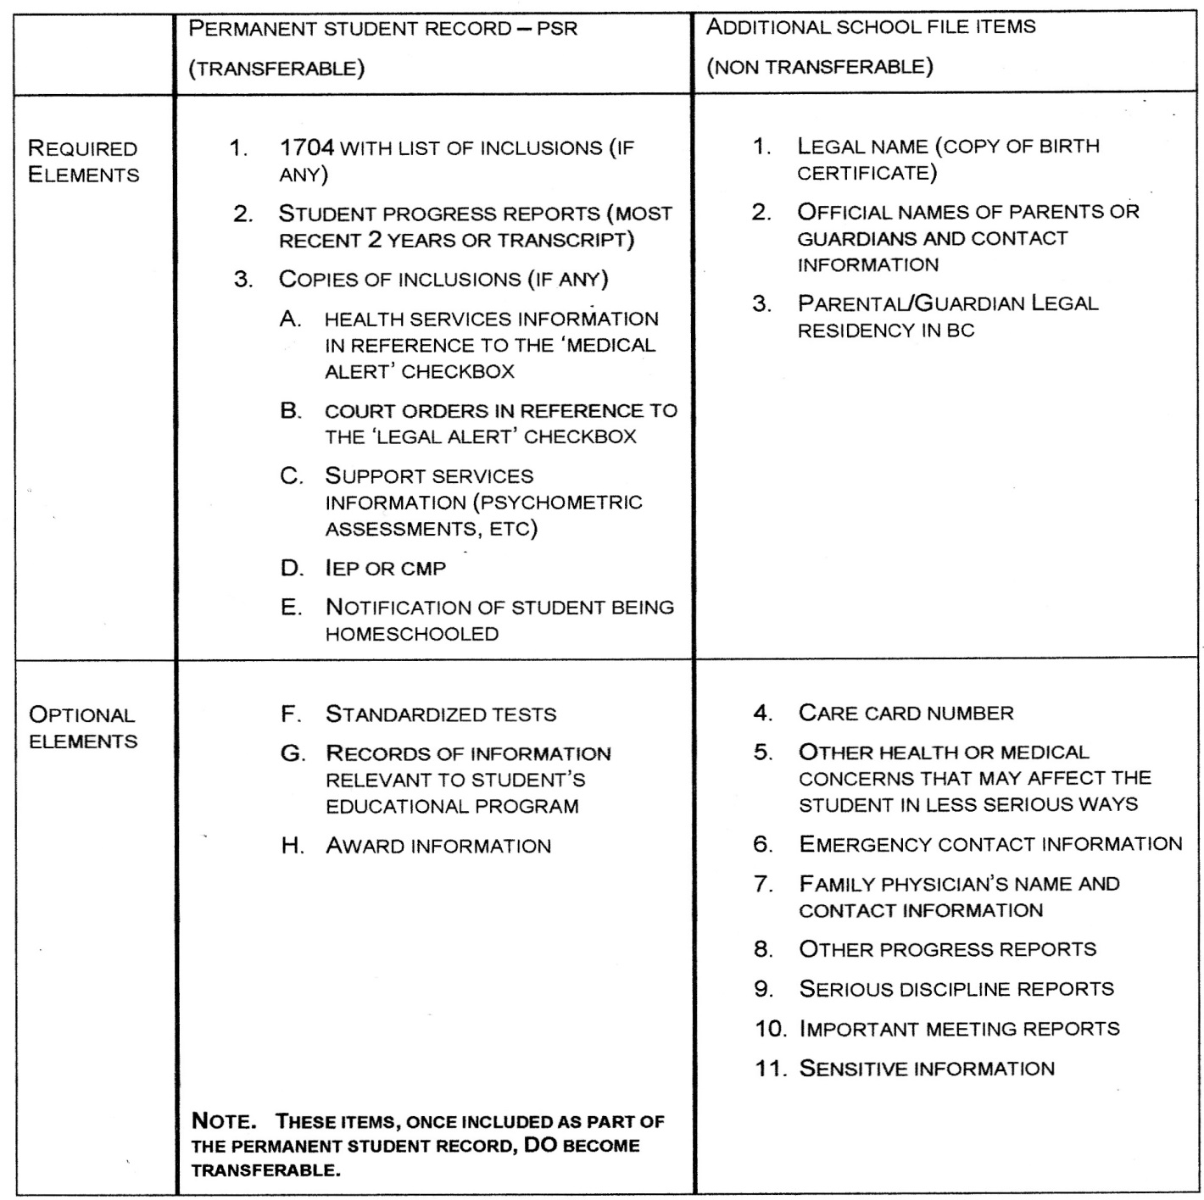
PART VI – QUICK REFERENCE CHART

APPENDIX I – ELIGIBLE STUDENT INFORMATION

Group 1 and 2 Independent School Grants
The following information may be helpful to schools, school authorities and school auditors
attempting to verify eligibility of certain students for provincial operating grants.
To be eligible the student’s parent/legal guardian must be:
• Lawfully admitted to Canada
• Resident of British Columbia

The Independent School Regulation reads as follows:
“eligible student” means a student
(a) who is of school age, and
(b) whose parent or guardian
(i) is, or was at the time of that parent's, or guardian's death, a citizen of Canada, or a
permanent resident, as defined in the Immigration and Refugee Protection Act
(Canada), who is, or was at the time of the parent's, or guardian's death, ordinarily
resident in British Columbia, or
(ii) is lawfully admitted to Canada and is ordinarily resident in British Columbia.
“guardian” means guardian of the person of a child within the meaning of the Family Relations
Act;

A parent or legal guardian is lawfully admitted to Canada within the meaning of paragraph
(b)(ii) of the above definition of an “eligible student” if he or she is in one of the following
categories:
• A person who has been determined under the Immigration and Refugee Protection Act
(Canada) to be a Convention refugee or refugee claimant
• Holder of a valid student permit issued for one year or more under the Immigration
and Refugee Protection Act (Canada)
• Holder of a valid work permit issued for one year or more under the Immigration and
Refugee Protection Act (Canada)
• Diplomat or consular official
Sample Student Registration Form sections to verify qualifying student status are attached as
Appendices II and III. These samples will meet Independent School Act requirements for
funding eligibility and require minimal collection of personal and/or original documents by the
school.

APPENDIX II – STATUS OF PARENT/GUARDIAN (ADMISSION TO CANADA AND RESIDENCY) - FORM A

(if parents are deceased, use Form B)

To be completed and signed by a parent or legal (court-appointed) guardian. (If legal guardian, attach copy
of court order appointing you as legal guardian).
(Lawfully Admitted into Canada)

1. I am (please X one):
□ A Canadian citizen (if not born in Canada, please attach a photocopy of citizenship
paper/card)
□ A Permanent Resident (landed immigrant) (attach photocopy of landed immigrant status
paper or PR card)
□ Lawfully admitted into Canada under the Immigration and Refugee Protection Act (Canada)
with one of the following documents (please mark the appropriate box below and attach
photocopy of document):
□ Admission as a refugee or refugee claimant
□ Valid student permit for two or more years (or issued for one year but anticipated to
be renewed for one or more additional years
□ Valid employment authorization (work permit) for two or more years (or issued for
one year but anticipated to be renewed for one or more additional years)
□ A person carrying out official duties under the authority of the Visiting Forces Act or as an
accredited diplomatic agent, preclearance officer, consular officer or official representative in
Canada of a foreign government with a consular post in British Columbia.
□ Other - Document description: (must be cleared with Citizenship and Immigration Canada)
(Residency in British Columbia)
2. I am a resident of British Columbia (please X one):
□ Yes Residency address:
□ No I am not a resident of British Columbia
Confirming signatures:
3. Parent/Legal Guardian’s name:
Parent/Legal Guardian’s signature:

APPENDIX III – STATUS OF DECEASED PARENT (ADMISSION TO CANADA AND RESIDENCY) - FORM B

To be completed and signed by the student or a knowledgeable adult (one who knew the student’s parent(s)
and has knowledge of the facts respecting their decease and the matters set out in this document)
(Deceased parent was Lawfully Admitted into Canada)

1. The student’s deceased Parent was at time of death:
□ A Canadian citizen
□ A Permanent Resident (landed immigrant)
(Deceased parent was Resident in British Columbia)

2. The student’s deceased parent was at time of death a resident of British Columbia (please X one):
□ Yes Residency address:
□ No I am not a resident of British Columbia

Confirming signature:
Student:
Knowledgeable Adult’s Name:
Knowledgeable Adult’s Signature:
(Knowledgeable Adult is one who knew the student’s parent(s) and has knowledge of the facts respecting
their decease and the matters set out in this document)
Date:

